Part Number: PW301-47000

Kit Contents (see next page for description)
Item # | Quantity Reqd. | Description
1 | 1 | Front cross bar
2 | 1 | Rear cross bar
3 | 2 | Cross bar rubber trim
4 | 2 | Key
5 | 4 | Insert
6 | 1 | Front Right Cover
7 | 1 | Front Left Cover
8 | 1 | Rear Right Cover
9 | 1 | Rear Left Cover
10 | 1 | Front Right Pad
11 | 1 | Front Left Pad
12 | 1 | Rear Right Pad
13 | 1 | Rear Left Pad
14 | 1 | Installation Torque Tool
15 | 1 | Installation Instructions
Hardware Bag Contents
Item # | Quantity Reqd. | Description
Additional Items Required For Installation
Item # | Quantity Reqd. | Description
Conflicts
None
Recommended Tools
Personal & Vehicle Protection | Notes
Blankets | Protect the roof
Special Tools | Notes
Installation Tools | Notes
Scissors
Tape Measure (Metric)
Nylon Panel Removal Tool | e.g. Panel Pry Tool #1  Toyota SST# 00002-06001-01
Special Chemicals | Notes
Cleaner | VDC Approved Surface  Cleaner
Soap & Water Solution | DIO Installations
General Applicability
All standard Prius models (does not fit Prius c or Prius v)
Recommended Sequence of Application
Item # | Accessory
1
2
3
*Mandatory
Vehicle Service Parts (may be required for reassembly)
Item # | Quantity Reqd. | Description
1
2
3
Legend
STOP: Damage to the vehicle may occur. Do not proceed until process has been complied with.
OPERATOR SAFETY: Use caution to avoid risk of injury.
CAUTION: A process that must be carefully observed in order to reduce the risk of damage to the accessory/vehicle and to ensure a quality installation.
TOOLS & EQUIPMENT: Used in Figures calls out the specific tools and equipment recommended for this process.
REVISION MARK: This mark highlights a change in installation with respect to previous issue.
SAFETY TORQUE: This mark indicates that torque is related to safety.

Care must be taken when installing this accessory to ensure damage does not occur to the vehicle. The installation of this accessory should follow approved guidelines to ensure a quality installation.

These guidelines can be found in the "Accessory Installation Practices" document.

This document covers such items as:-
- Vehicle Protection (use of covers and blankets, cleaning chemicals, etc.).
- Safety (eye protection, rechecking torque procedure, etc.).
- Vehicle Disassembly/Reassembly (panel removal, part storage, etc.).
- Electrical Component Disassembly/Reassembly (battery disconnection, connector removal, etc.).

Please see your Toyota dealer for a copy of this document.

Check the Kit & Warnings.
  - Verify the kit contents (Fig. 1-1).
    - A = Front & Rear cross bars
    - B = Covers (4 pcs) & keys (2 pcs)
    - C = Rubber pads (4 pcs)
    - D = Insert (4 pcs)
    - E = Installation tool (1 pc)
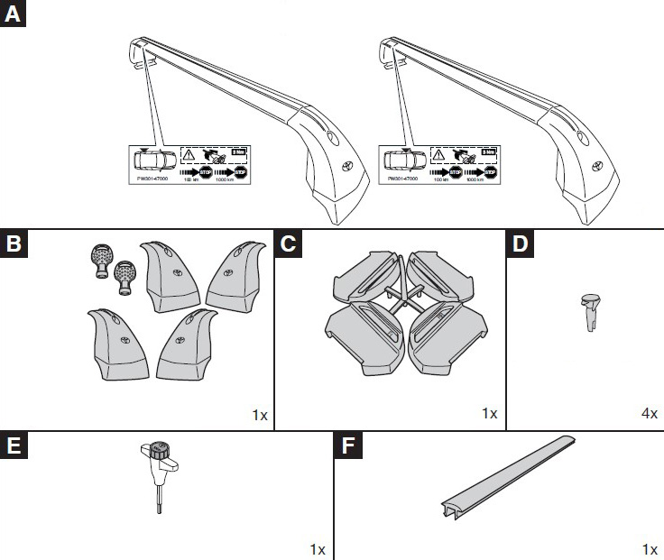
    - F = Rubber strip (2 pcs)
Fig. 1-1
Front
Rear

  - Safety notes:
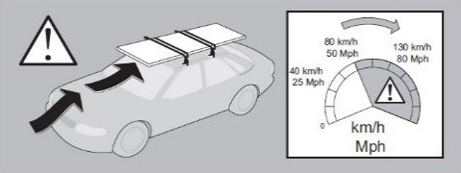
    - Use caution when carrying a load on the cross bars (Fig. 1-2).
Fig. 1-2

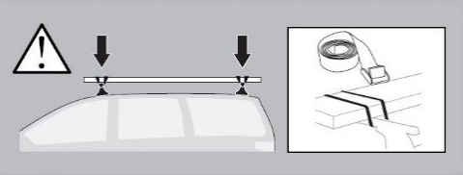
    - The load must be securely fastened to the cross bars (Fig. 1-3).
Fig. 1-3

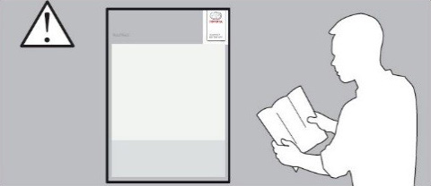
    - Make sure to read this entire manual before beginning the installation (Fig. 1-4).
Fig. 1-4

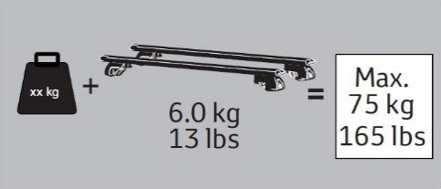
    - The maximum capacity of the cross bars is 165 lbs (75kg) (Fig. 1-5).
Fig. 1-5

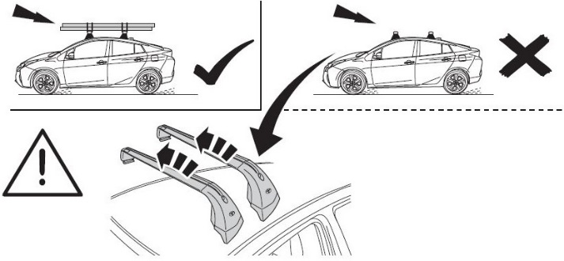
    - Remove the cross bars when no load is being carried (Fig. 1-6).
Fig. 1-6

Prepare to Install the Cross Bars.
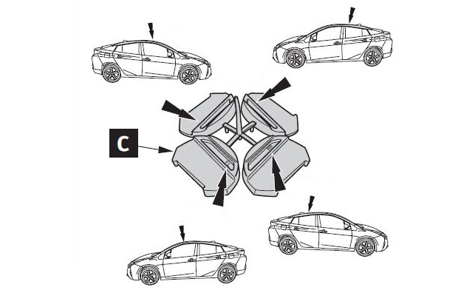
  - Locate the rubber pads and detach them from the excess material (Fig. 2-1).
Fig. 2-1

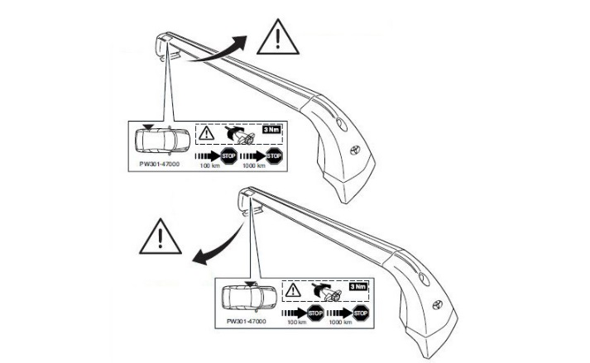
  - Identify where on the vehicle each cross bar foot will mount. Labels on the inside of the left side indicate the vehicle position, front or rear (Fig. 2-2).
Fig. 2-2
Rear/left
Front/left

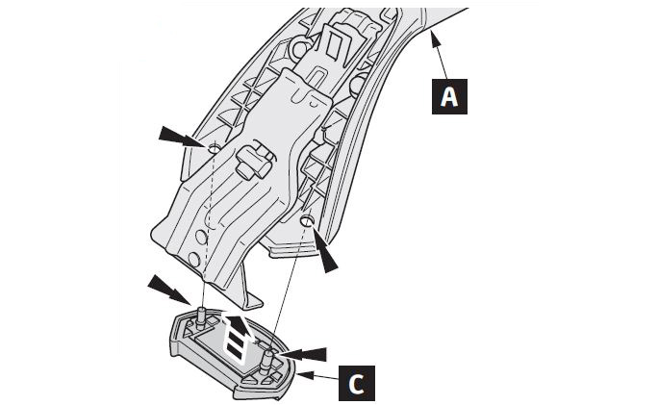
  - Install the rubber pads onto the bottom of the appropriate cross bar support. Each pad is marked with its location (Fig. 2-3).
Fig. 2-3

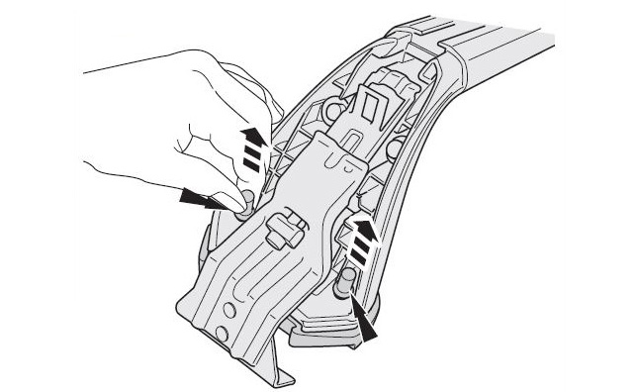
  - Pull up on the rubber tabs to fully seat the pad (Fig. 2-4).
Fig. 2-4
  - Protect the roof with a blanket.

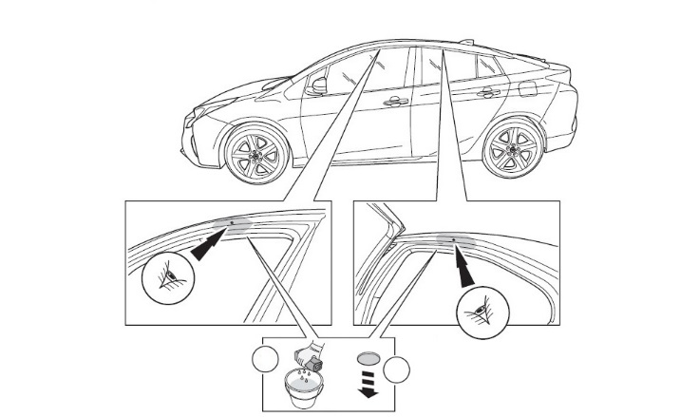
  - Open all four doors and clean the mounting indicated area with VDC-approved cleaner or soap and water solution (A, Fig. 2-5).
Fig. 2-5
Panel removal tool
A
B
  - Use a plastic prying tool to remove the 4 caps and discard them (B, Fig. 2-5).
  - Open the plastic bag and remove the 4 plastic inserts (Item D). Retain the bag for storing the keys and tool.

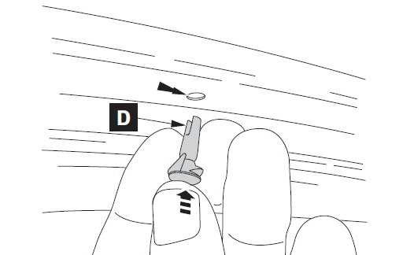
NOTE: Open the bag neatly for reuse.
Fig. 2-6
  - Install the inserts into each hole at the top of the door frame (Fig. 2-6).
  - Use the key to unlock and remove the plastic end covers.
  - Loosen the clamp assemblies enough to allow for installation.

NOTE: The clamp fastener will come off if loosened all the way.

Install the Front and Rear Cross Bars.
  - Be sure to use 2 people.
  - Do not move or slide the cross bar along the vehicle body.
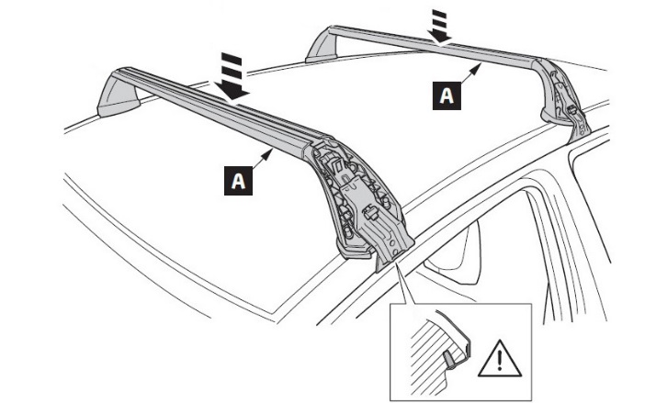
  - Carefully place the front crossbar with the pins fitted inside the front mounting holes (Fig. 3-1).
Fig. 3-1
  - Carefully place the rear crossbar with the pins fitted inside the rear mounting holes (Fig. 3-1).

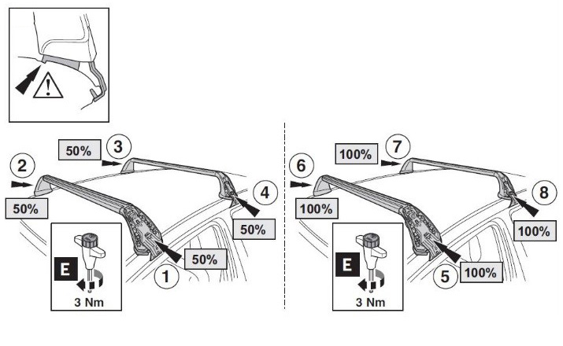
  - Ensure that the cross bar supports are placed properly onto the roof by making sure the rubber pad is fitted in the drip rail and the locating pins are fully seated into the holes in the door frame (Inset, Fig. 3-2).
Fig. 3-2
  - Use the installation tool provided to tighten each support half way (50%), then tighten each support until the installation tool clicks (100%) (Fig. 3-2).
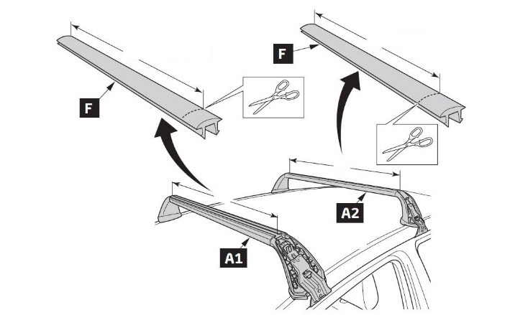
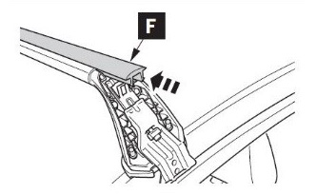
  - Cut the rubber insert to match the length of each cross bar, and slide them into position (Fig. 3-3 & Fig. 3-4).
Fig. 3-3
Scissors, measuring tape
a
b
a = 984 mm
b = 927 mm
Fig. 3-4

Complete the Installation.
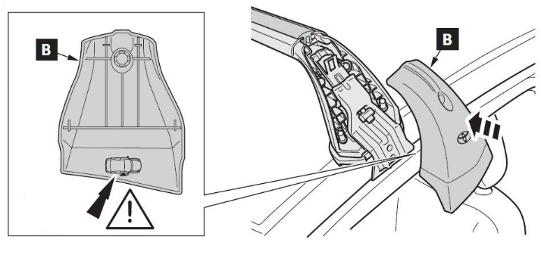
  - Install the covers onto each support. Each cover has its location shown on the inside surface (Fig. 4-1).
Fig. 4-1

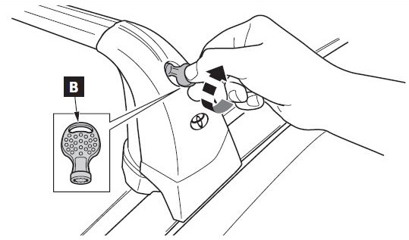
  - Use the key to lock the covers into position (Fig. 4-2).
Fig. 4-2

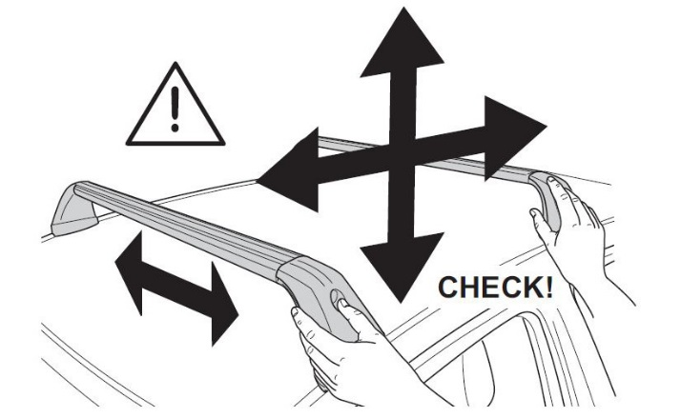
  - Check that the cross bars are tight and do not move (Fig. 4-3).
Fig. 4-3
  - Remove the key and place it in the original plastic bag.

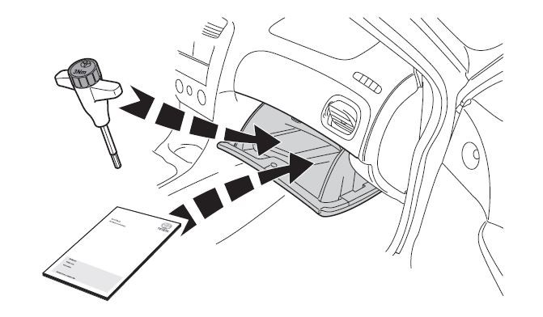
  - Place the bag with cover key, manual and installation tool in the glove compartment (Fig. 4-4).
Fig. 4-4

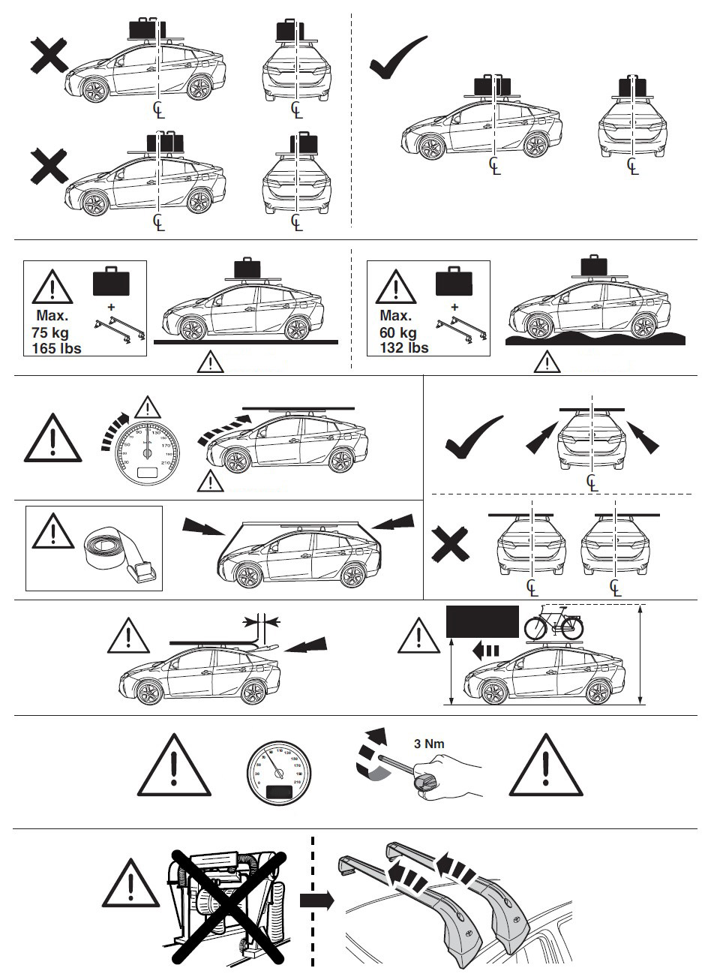
120 km/h or 75 mph
<120 km/h or 75 mph
120 km/h or 75 mph
100 km/h
60 mph

Accessory Function Checks
Ensure the cross bars are secure and in correct position

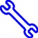
Ensure the covers are securely attached

Vehicle Function Checks

Cross bar knobs are tight and each clamp pin is properly inserted in the door frame hole
Covers are securely in place and locked

Vehicle Appearance Check
After accessory installation and removal of protective cover(s), perform a visual inspection.

Ensure no damage (including scuffs and scratches) was caused during the installation process.
(For PPO installations, refer to TMS Accessory Quality Shipping Standard.)

